07th March 2017

**YOKOHAMA Launches “BluEarth＊WINTER V905” New Winter Tyre for Passenger Cars and SUVs in Europe**

YOKOHAMA announced today that it will launch sales in Europe of a new winter tyre for passenger cars and SUVs from this autumn. The “BluEarth＊WINTER V905” will be available in 119 sizes, ranging from 295/30R22 103V to 195/80R15 96T.  
  
To meet Europe’s increasingly stringent environmental regulations, YOKOHAMA developed the “BluEarth＊WINTER V905” as the first YOKOHAMA-brand winter tyre to use the advanced technologies for which the Company’s fuel-efficient “BluEarth” tyres have become renowned. “BluEarth＊WINTER V905” is based on YOKOHAMA’s existing “W＊drive V905” winter tyre, which has been highly evaluated by ADAC Motorwelt, the official publication of Germany’s Allgemeiner Deutscher Automobil-Club (ADAC, the General German Automobile Club). The application of the “BluEarth” series’ basic design and materials technology to the existing “W＊drive V905” has resulted in a new winter tyre with superior stability and performance on ice, snow, and in wet and dry conditions, while also delivering superb fuel efficiency.   
  
“BluEarth" is one of YOKOHAMA’s global tyre brands. The Company also sells summer tyres, such as the “BluEarth AE-01” and the “BluEarth-A”, in overseas markets, including Europe and Russia.

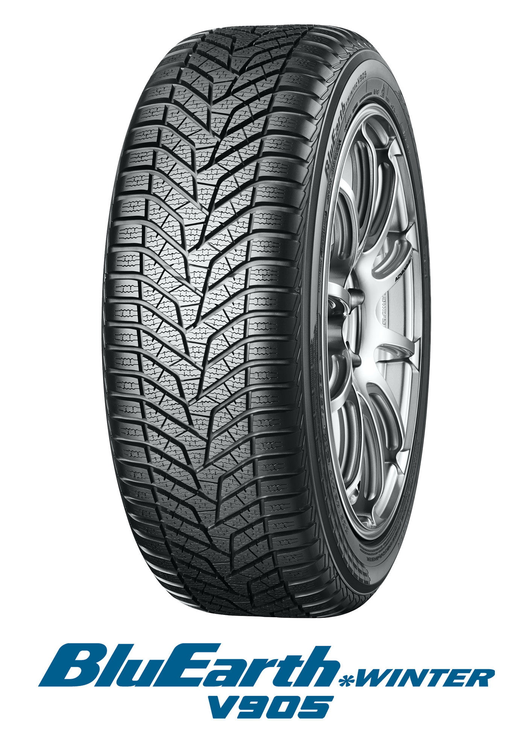

*BluEarth*WINTER V905*